Y1Q4W9

Elijah and the Fiery Chariot

Ask: Do you remember what the Bible says happens when you die?

Pictionary:
Ark, Colourful coat, Priest with budded staff, Water from rock.

Bible Story – Felts (Moses death; Elijah; Jesus and transfiguration)

Sing Songs

Return to tables
Memory Verse: Fill in the blanks and then say the memory verse on the colouring page.
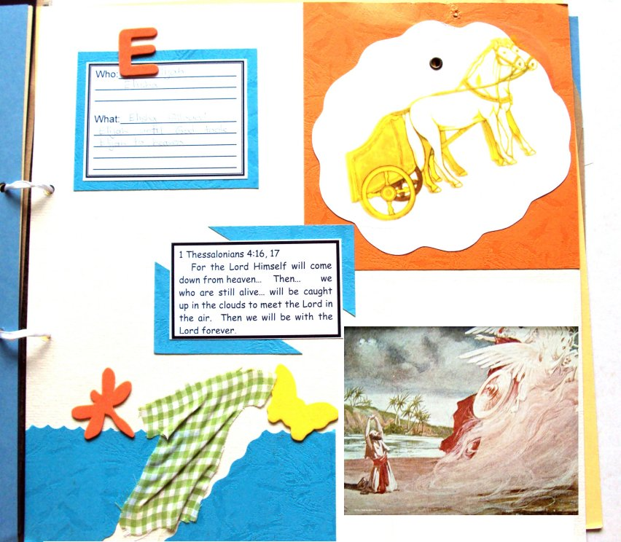
Scrapbooks
- Choose a cardboard
- Attach horses to cloud
- Stick on the picture, verse, description card and cloud with horses.
- Glue on water and robe and foam insect.

Discuss the following depending on age, interest and time:
Who is in Heaven now? (Enoch, Moses, Elijah, Jesus and some other people who loved Jesus who were raised to life when Jesus was raised to life.
What is similar between being unconscious and being dead? (You don't remember anything)
What is similar between being asleep and being dead? (You don't know how much time has passed)
Try and imagine what it must be like to be dead – like going to sleep and then waking up to see Jesus coming.
What will Heaven be like?
If it was true that people went to Heaven when they died and then watched all the things happening on earth do you think they would be happy? Would they ever feel sad? or angry? or jealous?

Ask: What do we have to do to go to Heaven?
Say: We need to ask Jesus to forgive us and to take our punishment (which is being dead forever).
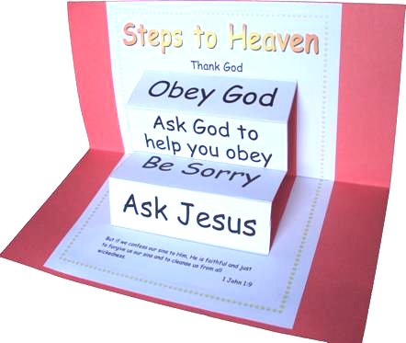
Primary/Junior: Steps to Heaven Craft
- Fold the printed cardboard in half along the centre line.
- Use scissors to cut along the vertical lines at the sides of the steps.
- Fold the cardboard in half the other way and fold out the steps.
- Glue the cardboard into a piece of scrap-booking card folded in half.

Primary / Junior / Teen: This term, those of you who would like to get a Bible to take home, may take one of the orange Commandment pages and add to your book. Each week you come you can put a sticker on it and when it is all complete we will get you a Bible to take home and keep.

Pray: That God will help us all to make good choices, and that we will all meet again in Heaven.

